Sona BLW Precision Forgings (SONACOMS.IN)
EV growth resuming, growth base broadening – Upgrade to Outperform
Rating: Outperform (prev. Market-Perform) Price Target: Rs720 (prev. Rs540)
Close: Rs617 Upside: ~17% FYE: Mar India SMID · Automobiles · 23 June 2026 · Param Shah

We upgrade Sona BLW to Outperform with a revised target of Rs720 (from Rs540). A year ago we moved the stock to Market-Perform because its earnings had become closely tied to US EV volumes and to one large US EV customer, both of which were slowing. The EV demand backdrop has since begun to improve, and the base of Sona’s growth has broadened well beyond the US. We now expect growth to be led by resuming EV demand, with India in front; by higher content per vehicle and new customer wins; by lower-cost and localised EV platforms; by new, differentiated products; and by a growing railway business. Newer businesses in sensors, radar and robotics add nearer-term optionality than the market assumes. We raise our FY27-28 estimates above consensus and lift our DCF-based target accordingly.
Our June 2025 downgrade rested on five points: US EV unit growth was slowing; US EV policy had turned less supportive; Sona’s largest customer, a top US EV OEM at 15-20% of revenue, was losing share; legacy OEMs were deferring EV plans; and 77% of the order book was tied to EVs. Most of these observations were correct. But the company reduced its dependence on them faster than they could affect earnings. Two of the five concerns have now resolved, and a third has receded.
What has changed is the breadth and quality of Sona’s growth, not a switch from one driver to another. EV volumes still matter, and the demand backdrop is improving. Alongside volumes, Sona is moving up the value chain, from individual components toward assemblies and integrated systems, which raises its content per vehicle; it is adding new customers, including beyond the traditional OEMs it has historically served, as its FY26 annual report sets out; and it is a clear beneficiary of supply chains diversifying toward India under “China plus one”. It is also winning content on lower-cost, higher-volume platforms and bringing genuinely new products to market. The result is growth that depends less on any single market or customer than it did a year ago.
The stock is not cheap. It has risen about 26% over the past year and trades near its 52-week high. On trailing earnings the multiple is high, but this is distorted by the railway consolidation and one-off items. On our FY27 estimates the stock trades at about 41x forward, below its three-year average of 46x, for a business we expect to grow earnings in the mid-twenties. Our Rs720 target is DCF-based, implies about 48x FY27, and assumes the multiple holds rather than expands.
Investment Implications
With EV demand resuming, the growth base broader across new clients, lower-cost platforms and new products, customer concentration lower, a growing railway stream, and our estimates above consensus, we upgrade to Outperform with a DCF-based target of Rs720 (from Rs540). The main risk to the call is valuation. The main near-term risk to earnings is margin volatility from several programs ramping at once.

Upgrade to Outperform
We upgrade Sona to Outperform. The growth story has broadened: an improving, India-led EV demand backdrop; higher content per vehicle and new customer wins; lower-cost and localised platforms; new differentiated products; and a growing railway business, with sensors, radar and robotics adding nearer-term optionality. We raise FY27-28 estimates above consensus and lift our DCF-based target to Rs720 from Rs540, driven mainly by a higher medium-term growth assumption, a one-year roll-forward of the model, and the full-year contribution of the railway business.
EXHIBIT 1: Change in estimates
Change in estimates | Mar-26A | Mar-27E | Mar-28E
Revenue – New | 47,300 | 58,800 | 71,500
Revenue – Old | 45,336 | 53,544 | 64,717
Change (%) | +4.3% | +9.8% | +10.5%
EBITDA – New | 12,300 | 15,300 | 18,800
EBITDA – Old | 11,861 | 13,637 | 16,287
Change (%) | +3.7% | +12.2% | +15.4%
PAT – New | 7,450 | 9,400 | 11,500
PAT – Old | 7,287 | 8,159 | 9,952
Change (%) | +2.2% | +15.2% | +15.5%
Source: Company data (Mar-26A); Bernstein estimates. Estimates are an illustrative framework – reconcile to live model before publication.
Exhibit 2 sets out how the five concerns behind our downgrade now stand. Two have resolved, two have been mitigated, and one, US policy, remains in place but matters less because Sona is growing away from the US.
EXHIBIT 2: Status of the five concerns behind our June-2025 downgrade
Downgrade concern (Jun-25) | What we feared | Where it stands now
US EV unit growth | Slowing in Sona’s key market | Improving – growth resuming, India-led; global ~20%
US EV policy | Subsidy / EPA / California rollback | In place – but Sona is growing away from the US
Customer concentration | Top US EV OEM 15-20% of revenue, losing share | Resolved – a leading Indian 2W OEM is now largest EV customer
Legacy OEM EV deferrals | Order-book execution slips | Mitigated – broader base; India and China ramping
No China exposure | Cannot benefit from fastest-growing EV market | Resolved – now a content source (premium China EVs)
Source: Bernstein (prior published note, Jun-25); company management call; Bernstein analysis.
Thesis
#1 EV growth is set to resume, led by India, with the top US customer now a small part of the mix
The starting point of our downgrade was a weakening EV demand backdrop concentrated in the US. That backdrop has turned, and we expect EV growth to resume from here, led by India and supported by China, with the US stabilising. In the US, new EV sales are still below year-ago levels, but the year-on-year decline has narrowed to its smallest since incentives were withdrawn, and month-on-month volumes have turned up. Globally, EV sales continue to grow at around 20%, led by China and Europe.
EXHIBIT 3: US EV sales: the year-on-year decline is narrowing (% YoY)
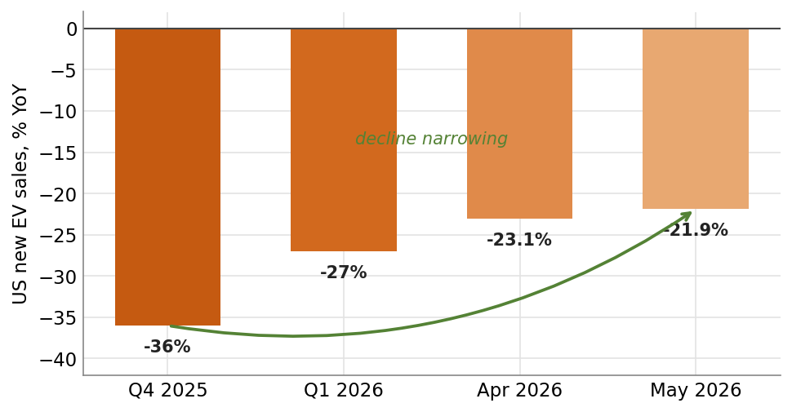
Source: Cox Automotive / Kelley Blue Book (US, BEV+PHEV); Bernstein analysis. Global growth ~20% YoY, led by China and Europe. Reconcile to internal monthly tracker before publication.
The growth that matters most for Sona is now in India. India two- and three-wheeler electrification is running well ahead of passenger vehicles, and Sona is gaining share there. At the same time, Sona’s dependence on the US has fallen. Its largest customer at the time of our downgrade, a top US EV OEM at 15-20% of revenue, is now a smaller part of the mix; management indicates it is no longer relying on this customer for growth, and a leading Indian two-wheeler OEM is now the largest EV customer in the book. The top US customer’s volumes are still soft, and we have modelled that, but it can no longer swing a quarter on its own.
EXHIBIT 4: Revenue base shifting from West to East (% of revenue)
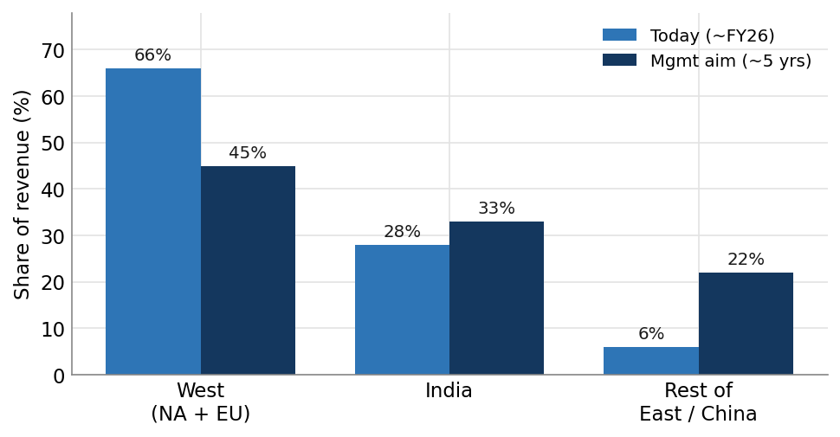
Source: Company management commentary (five-year aim, management-indicated); Bernstein analysis.
We would not call a durable US recovery on two months of data, and we are watching whether it sustains. But the composition of Sona’s growth has shifted toward the markets that are actually growing. The demand backdrop has stopped working against Sona, and in India and China it is working for it.
#2 Rising content per vehicle and new client wins are broadening the base
The second driver is the content Sona earns on each vehicle, which is rising as the company moves up the value chain. Sona is shifting from supplying individual gears and components to complete differential assemblies and, increasingly, integrated systems. This lifts its content per vehicle well above the value of a standalone part, on the same vehicle and at the same volume. Differential gears, where Sona already holds a high single-digit share of the world market, grow more slowly; the assemblies and integrated content are the faster-growing, higher-value layer.
The motor business shows the same pattern. Supplying an integrated motor-and-controller unit, rather than a motor alone, raises content per vehicle by a meaningful margin on each two- and three-wheeler. This is visible in the traction-motor line, which has grown from about Rs0.2bn in FY22 to an estimated Rs4.5bn in FY27 and is the fastest-growing line in the company.
EXHIBIT 5: Traction motor revenue (Rs mn)
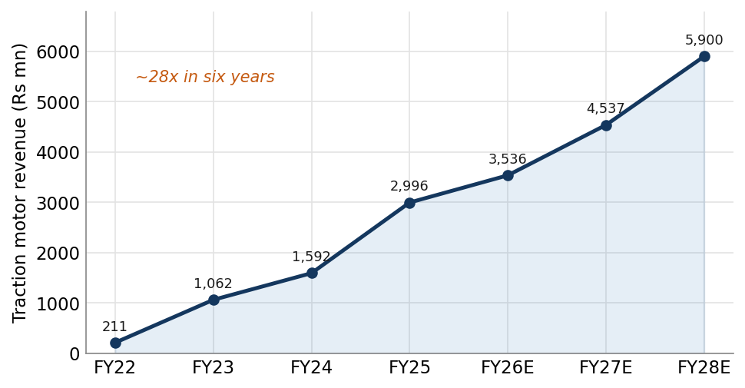
Source: Company filings (FY22-FY27); FY28E illustrative; Bernstein analysis.
Alongside higher content, Sona is adding new clients, and widening its base beyond the traditional OEMs it has historically supplied. Its FY26 annual report makes this explicit: the company is no longer focused only on traditional OEMs and is adding newer, EV-native customers. The order book now spans a large Indian PV/3W OEM’s BEV platform, a UK luxury OEM’s EV launches, a US OEM’s electric pick-up program, the leading Indian 2W OEM, a premium Chinese EV maker, and a widening set of India 2W/3W programs.
The Q4 FY26 investor presentation points the same way. The number of programs in ramp-up is rising, which is a leading indicator of revenue, and the EV order book is growing. A rising count of ramping programs alongside a rising order book gives us more confidence in the revenue trajectory than order-book size alone, and it underpins the above-consensus estimates we set out below.
#3 Lower-cost and localised EV platforms expand the addressable market
A third driver, and one we think is underappreciated, is the move toward lower-cost and localised EV platforms. As EVs broaden from premium models to mass-market and value platforms, volumes rise, and Sona’s localised, cost-competitive content travels with them. India two- and three-wheelers are the clearest example: low-cost, high-volume platforms electrifying quickly, where Sona is winning share.
This sits within a larger shift. As global manufacturers diversify their supply chains away from China under “China plus one”, India is emerging as a preferred alternative, and India-based component makers with their own technology are well placed to take that share. On some platforms, components that were previously imported are now sourced locally from Sona, which wins content and reduces import and currency frictions.
The competitive landscape supports the durability of these wins. The market-leading PV OEM is building its electric driveline through a consortium with Japanese partners; another large OEM relies on a supplier with a high share of Chinese imports; a further OEM is largely import-dependent. A domestic supplier with its own motor and controller technology, winning share on low-cost platforms, is well placed. Channel checks support this: the leading 2W OEM is running very lean dealer inventory of about two days, indicating strong demand, while another large 2W OEM’s EV business is outsourced and loss-making.
#4 New products are moving Sona into higher-value, differentiated parts
Sona is also adding genuinely new products that carry higher value and face less competition. The clearest current example is the suspension motor for premium Chinese EVs. Each premium model from one Chinese EV maker uses a suspension motor that applies counter-force to the chassis. Sona supplies this hardware at a price well below incumbent active-suspension systems, on premium SUVs in the luxury price range, at modest but high-value monthly volumes. Management aims to extend this to more models from the same maker and to win other Chinese OEMs.
The next step is high voltage. Sona is moving toward high-voltage motors and controllers for cars and trucks. It does not make these today, but it is developing them, and they carry a much higher content per vehicle than the driveline parts that dominate the current book. If Sona converts this capability into programs, it would lift content per vehicle materially in four-wheelers and commercial vehicles, the two segments where its content today is lowest relative to the value of the vehicle. We treat this as a medium-term driver, but it is a meaningful extension of the content theme and one of the larger long-run prizes.
These products matter for two reasons. First, the suspension motor gives Sona exposure to China, the one large EV market it previously could not serve. Second, both are differentiated, high-content parts where competition is thinner and margins better than in commodity driveline components. China carries risk as well as opportunity: relationships there can be price-aggressive and less stable, the premium maker in question is not a financially strong counterparty, and the rare-earth magnet supply issue that disrupted production in 2025 remains relevant to Sona’s motor business. On a twelve-month view we think the content outweighs these risks, but we treat them as live.
#5 The railway business is expanding and adds a non-EV earnings stream
The consolidation of the railway equipment business adds an earnings stream unrelated to electric cars, US policy, Chinese OEMs, or rare-earth magnets. We estimate it builds toward about Rs11bn of revenue in FY27, and management is expanding it with new products rather than treating it as a static line.
This is not a high-growth business and is not the main reason for the upgrade. But it diversifies the earnings base away from the cyclical, policy-sensitive auto lines that drove our 2025 view, it is largely domestic, and it adds stability to consolidated earnings.
EXHIBIT 6: Segment revenue including railway (Rs mn)
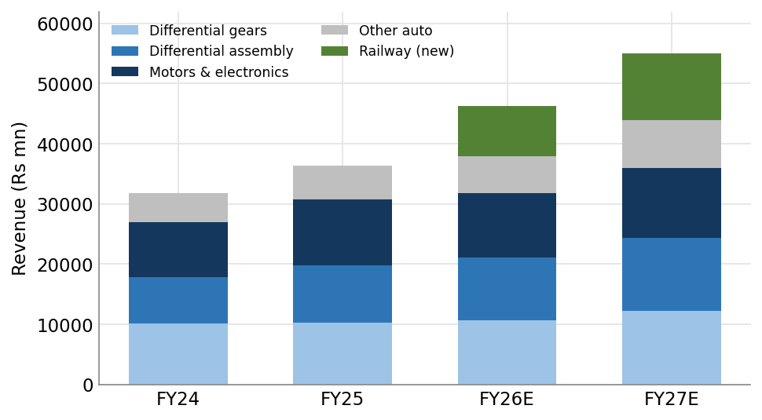
Source: Company filings; railway from FY26E on consolidation; FY27E Bernstein estimates. Motors grouped; figures illustrative of mix.
#6 New businesses in sensors, radar and robotics will scale sooner than the market expects
Sona is building a set of new businesses beyond the powertrain that the market still treats as distant. We think the timeline is shorter than that, and in one case it is already near-term.
The clearest example is sensing and radar. Sona has short-range radar and sensing technology suited to blind-spot detection. This matters now because of regulation. Under new MoRTH rules, commercial vehicles, trucks and buses, must carry a blind spot information system as part of a wider mandated ADAS suite, phased in over the next two years; the blind-spot standard (AIS-186) applies to heavy trucks within this window. Short-range radar of the kind Sona makes is precisely what this requires. A regulated, time-bound demand for blind-spot sensing across India’s large commercial-vehicle fleet is a concrete, near-term driver, not optionality.
This is already visible in the accounts. The sensors and software line is small but the fastest-growing in the company, building from a low base toward an estimated Rs1.3bn in FY27, and the commercial-vehicle ADAS mandate adds a further leg to it.
EXHIBIT 7: Sensors & software revenue (Rs mn)
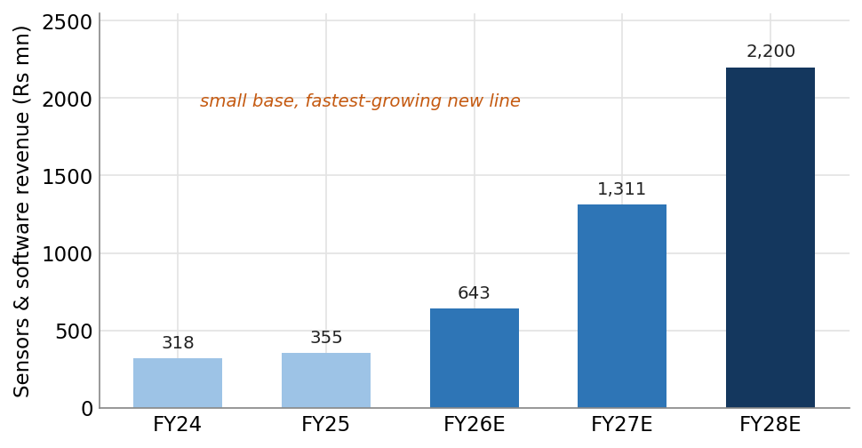
Source: Company filings (FY24-FY27E); FY28E illustrative; Bernstein analysis.
Robotics is the next leg. Sona has approved capex of about Rs60 crore (Rs0.6bn) for robotics components, a concrete commitment rather than a slideware ambition. Taken with the sensor ramp and the ADAS mandate, this tells us these new businesses will start to recognise revenue sooner than the market is crediting. That is upside to our estimates, not a risk to them.
We continue to treat humanoids and drones, and the high-voltage motor opportunity above, as longer-term optionality outside our base case and target. But the direction is clear. Sona’s product engine is widening well beyond driveline parts, drawing on the same core competence in precision motors, controllers and sensing. The market is slow to give a parts maker credit for this. We think it should.
Valuation: full but not stretched for the growth
The stock is not cheap, and we are recommending it close to its 52-week high after a 26% rise over the past year. On trailing earnings the multiple is in the high-50s. We think this overstates the operating multiple, as it is affected by the railway consolidation and one-off items.
The more relevant measure is the forward multiple against growth. On our FY27 estimates, which are above consensus, the stock trades at about 41x, below its three-year average of 46x. For a company growing earnings in the mid-twenties, with a broader growth base and lower customer concentration, we view this as fair to attractive.
EXHIBIT 8: 12-month forward P/E versus 3-year band (x)
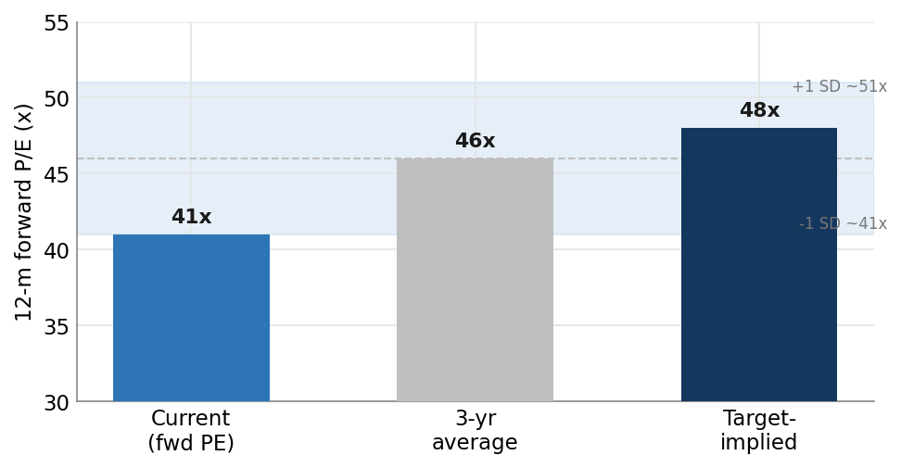
Source: Bloomberg (historical band); Bernstein estimates. Forward P/E on Bernstein FY27 EPS; band stylised to the 3-year average.
Our target of Rs720 is DCF-based and assumes the forward multiple holds near its average, at about 48x FY27, rather than expanding. The increase from our previous Rs540 target comes from three sources: a higher medium-term growth assumption, a one-year roll-forward of the model, and the full-year contribution of the railway business with a slightly better mix. We value the stock on discounted free cash flow, with an FY38 terminal year, 5% terminal growth and an ~11% WACC; the sensor, radar, robotics, humanoid and high-voltage opportunities are treated as optionality and are not in the target.
EXHIBIT 9: DCF bridge: Rs540 to Rs720 (Rs/share)
Bridge to target | Rs / share
Old target (Jun-25, DCF) | 540
Roll-forward one year (FY26 into base) | +55
Higher medium-term growth (22% to ~26% FY26-31E) | +95
Railway full-year + mix / margin | +30
New target (Outperform) | 720
Source: Bernstein DCF (FY38 terminal year, 5% terminal growth, ~11% WACC). Illustrative framework – reconcile to live model before publication.
EXHIBIT 10: Estimates versus consensus
Rs mn (unless stated) | FY26A | FY27E new | FY27E old | FY28E new | FY28E old
Revenue | 47,300 | 58,800 | 53,544 | 71,500 | 64,717
EBITDA | 12,300 | 15,300 | 13,637 | 18,800 | 16,287
EBITDA margin | 26.0% | 26.0% | 25.5% | 26.3% | 25.2%
PAT | 7,450 | 9,400 | 8,159 | 11,500 | 9,952
EPS (Rs) | 12.0 | 15.1 | 13.1 | 18.5 | 16.0
vs consensus (PAT) | — | +5% | — | +5% | —
Source: Company filings (FY26A); Bernstein estimates; Bloomberg-compiled consensus. Estimates are an illustrative framework – reconcile to live model before publication.
Key risks
The main risk to our Outperform rating is valuation. At a full forward multiple, Sona has limited room for disappointment, and a broad de-rating of high-growth Indian mid-caps would affect it regardless of operating performance. The main near-term earnings risk is margin volatility from several programs ramping at once; management has indicated this can cost 200-300bps in a heavy-launch quarter, which could produce a weak quarter and a sharp share reaction. The EV demand recovery is still young, and a renewed slowdown, particularly in the US, would undercut part of the thesis. Over a longer horizon, the China content that supports part of the growth case carries geopolitical, counterparty and rare-earth-supply risk. The new businesses in sensors, radar and robotics could ramp more slowly than we expect, in which case the upside we describe would take longer to appear; we do not rely on them in our base case or target. Slower India 2W/3W electrification, or share loss in differential assemblies, are further downside risks.
Data note and methodology
The hard data in this note (segment revenues, order-book mix, historical financials) are drawn from company filings and presentations, including the FY26 annual report and the Q4 FY26 investor presentation. EV-market figures are from public industry trackers and should be reconciled with our internal monthly data before publication. The commercial-vehicle ADAS mandate is referenced from MoRTH notifications (GSR 184(E) and subsequent); timelines are phased over 2026-2028 and should be confirmed against the final rules. The approved robotics capex (about Rs60 crore) is company-disclosed. Forward-looking commentary on customers, content per vehicle, China programs, high-voltage products and competitive positioning is sourced from a recent management call and company disclosure; we have described content gains in qualitative terms and have leaned the exhibits on reported segment revenues rather than per-unit pricing, which is softer intelligence. Customer relationships are described generically, as specific customer names are not public. The financial estimates and the DCF bridge shown here are an analyst framework, anchored to a Rs720 DCF-based target (FY38 terminal year, 5% terminal growth, ~11% WACC), and are to be reconciled against the live model before publication. Sensors, radar, robotics, humanoids, drones and high-voltage motors are treated as optionality and are not in the base case or target. References to consensus use Bloomberg-compiled estimates. Share price and performance data as of 22 June 2026.

